# Chapter 1: Introduction

This documentation provides a step-by-step guide on installing Laravel and Node.js on a development environment. Laravel is a popular PHP framework for web application development, while Node.js is a runtime environment for executing JavaScript outside the browser. The installation process includes Installing PHP and the Laravel installer, and the initial configuration.

# Chapter 2: Installation

## 2.1. Installing PHP and the Laravel Installer

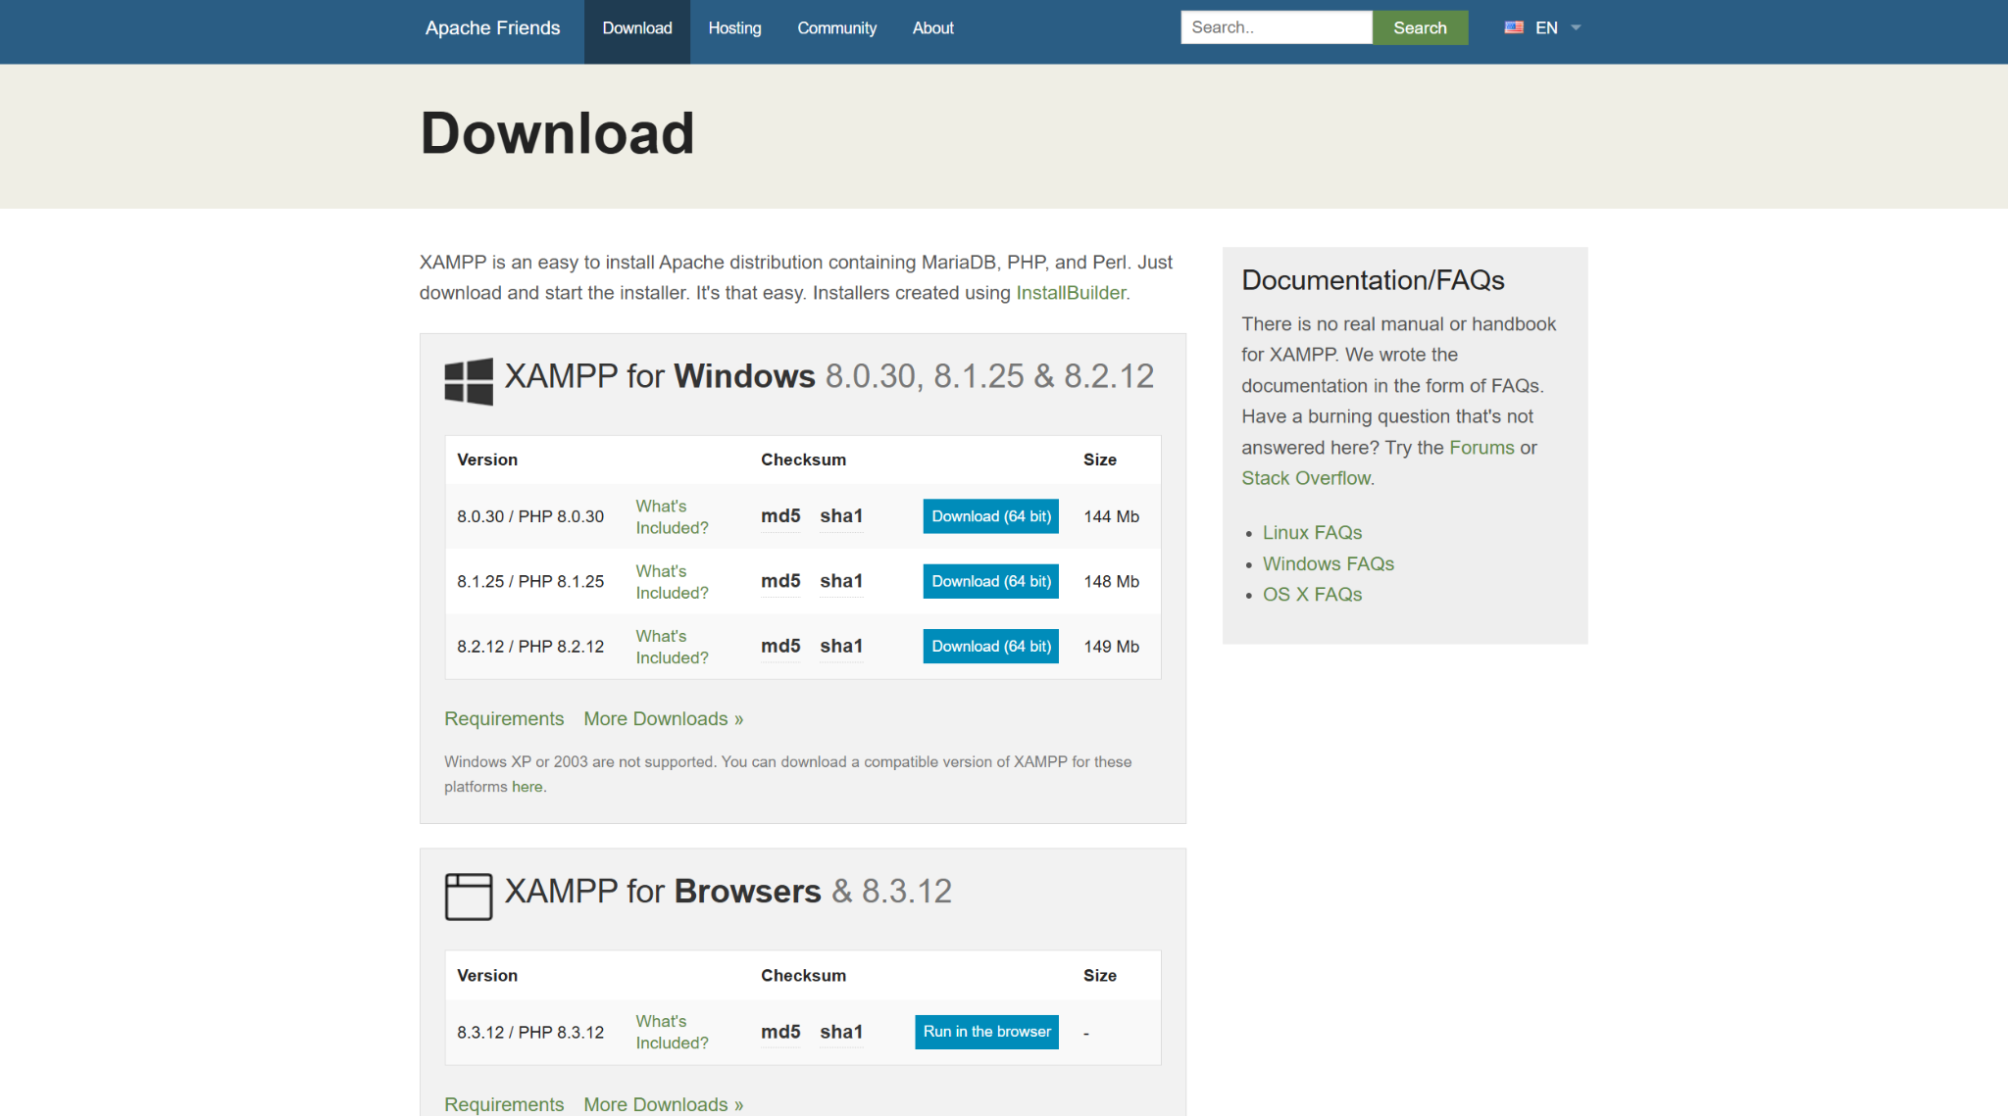

Figure 1. Downloading XAMPP Installer from it’s website

navigating to the official XAMPP website and downloading the appropriate installer for setting up a local development environment.

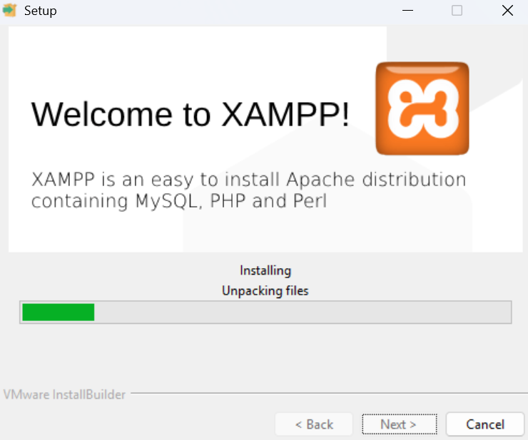

Figure 2. XAMPP installation

Shows the installation process of XAMPP, which includes selecting components, installation directory, and finalizing the setup.

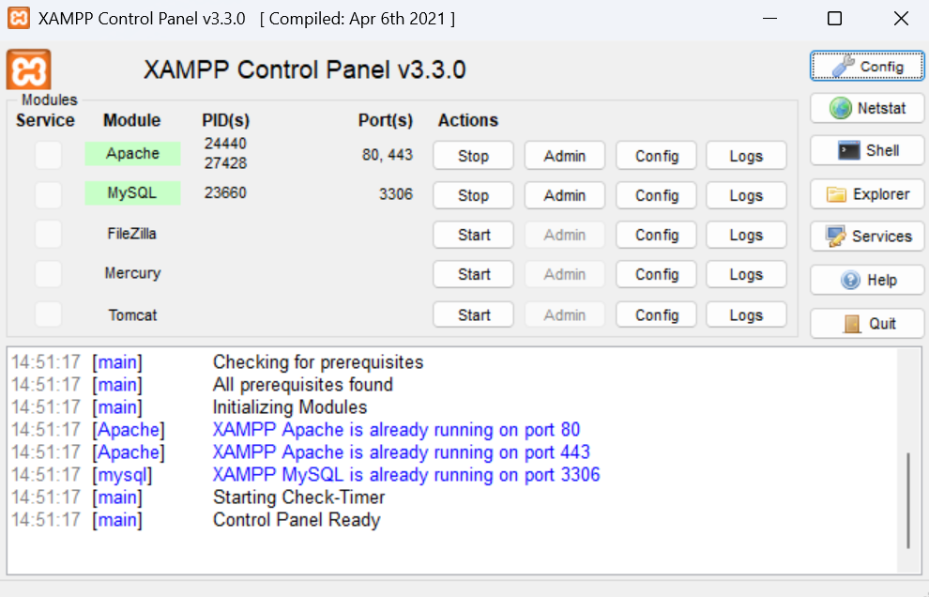

Figure 3. XAMPP control panel

Displays the XAMPP control panel, where users can start Apache and MySQL services needed for Laravel development.

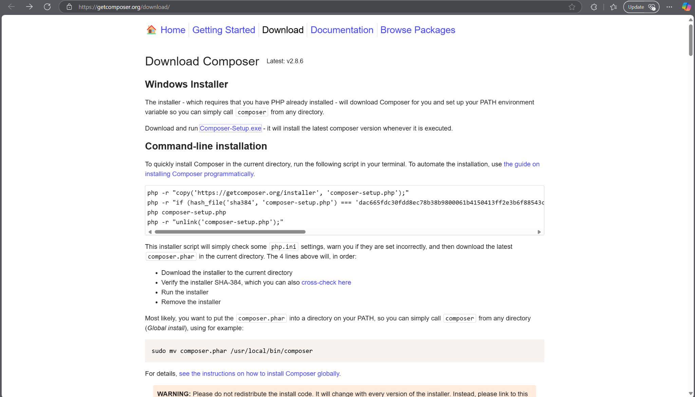

Figure 4. Downloading Composer Installer from it’s website

Illustrates the process of downloading Composer, a dependency manager for PHP, from its official website.

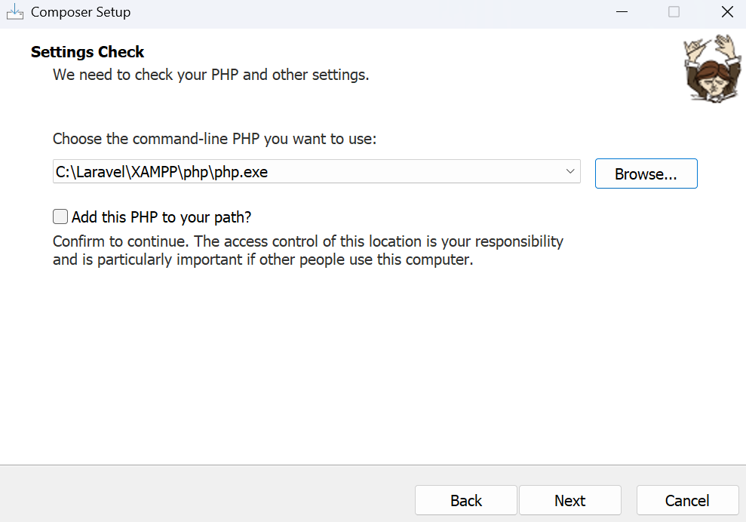

Figure 5. Composer setup

Shows the Composer installation wizard, where users configure PHP paths and complete the setup.

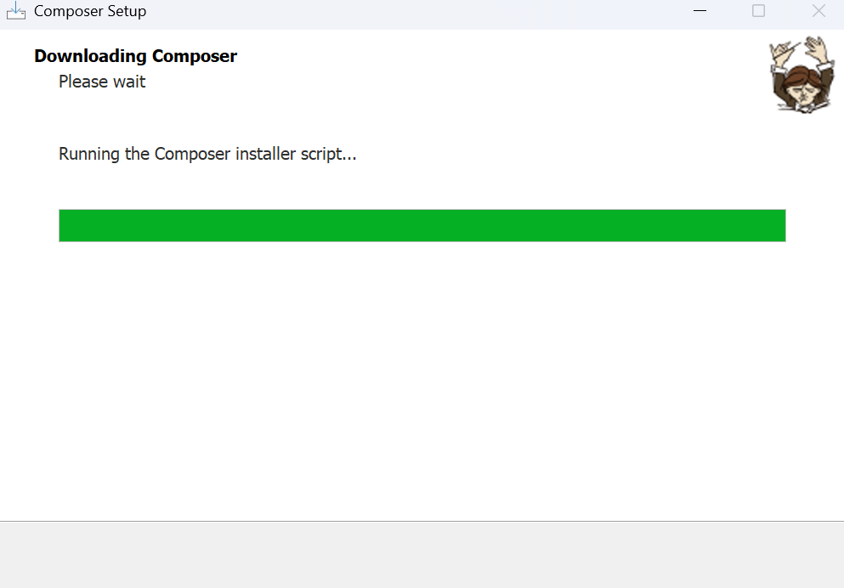

Figure 6. Composer installation

Depicts the finalization of the Composer installation process, ensuring it is ready for use.

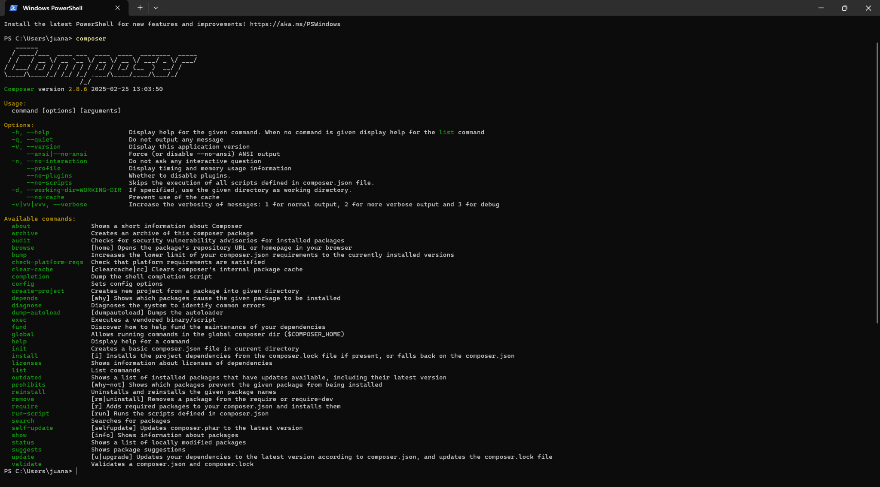

Figure 7. Accessing Composer from terminal

Demonstrates how to verify Composer installation by running the ‘composer’ command in the terminal.

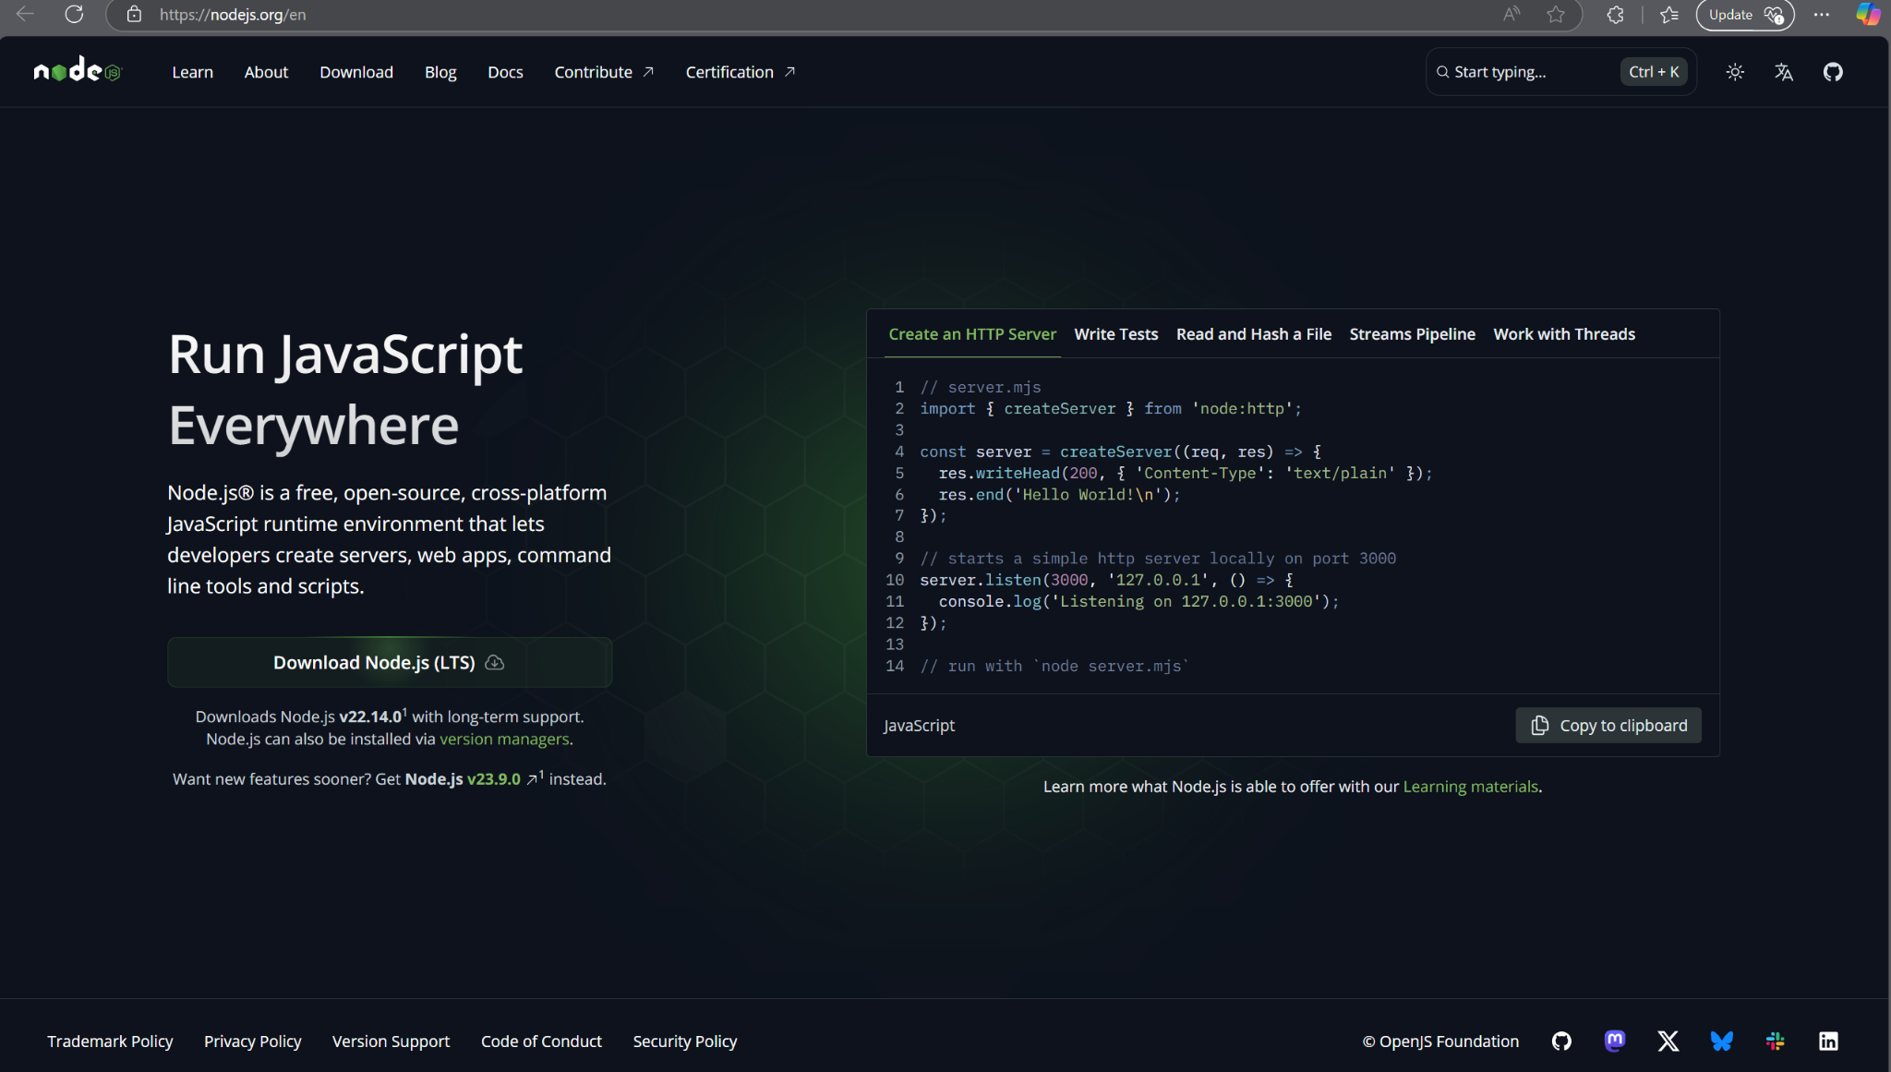

Figure 8. Downloading Node.js from it’s website

Illustrates the process of downloading Node.js, which is required for Laravel’s frontend dependencies.

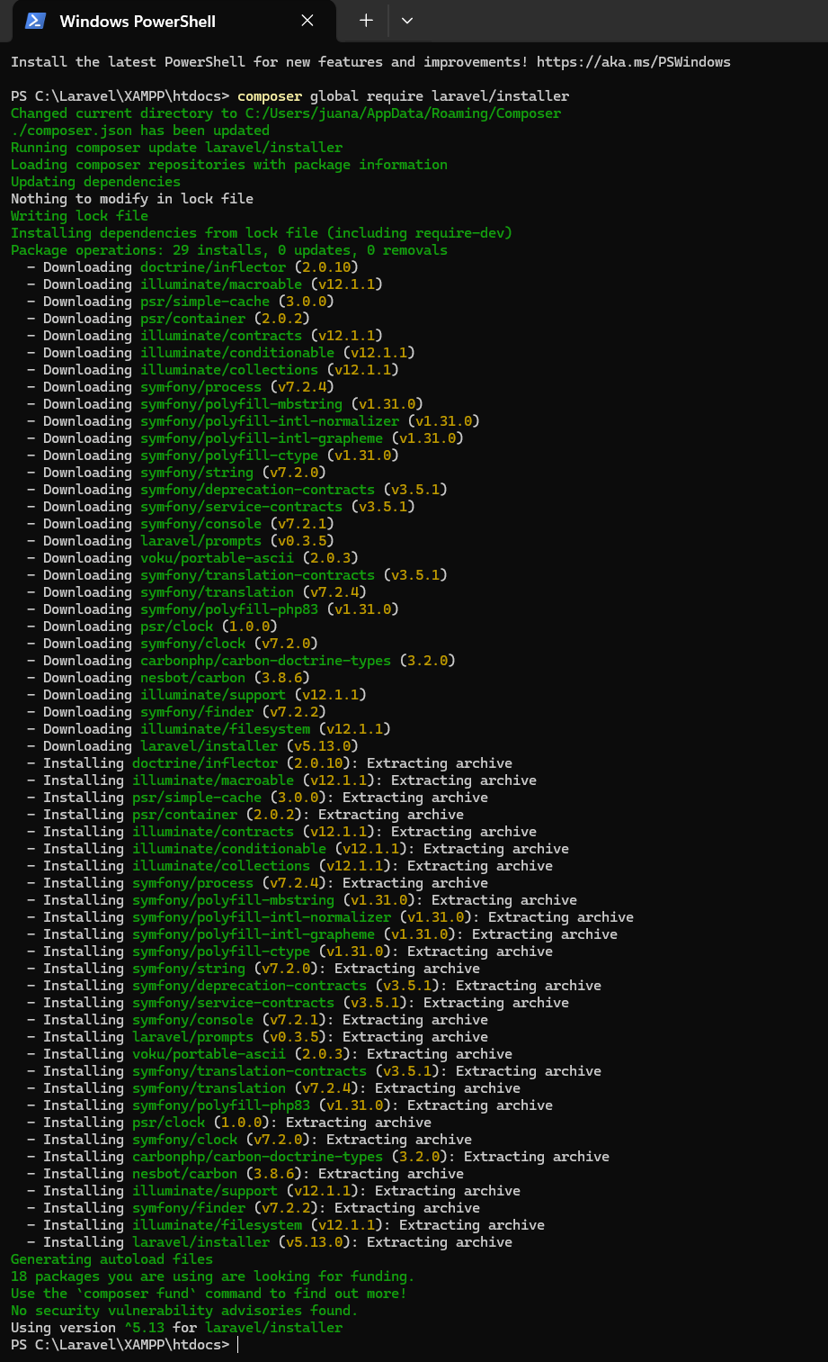

Figure 9. Installing Laravel via Composer

Shows the command used to install Laravel globally using Composer

## 2.2. Creating a Laravel Application

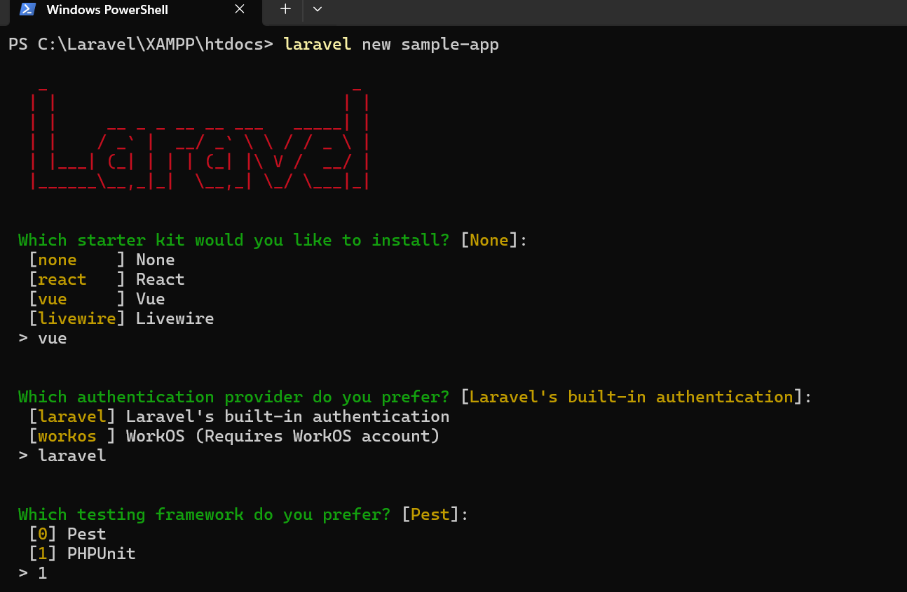

Figure 10. Creating a new Laravel application

Displays the execution of the ‘laravel new sample-app’ command to create a fresh Laravel application.

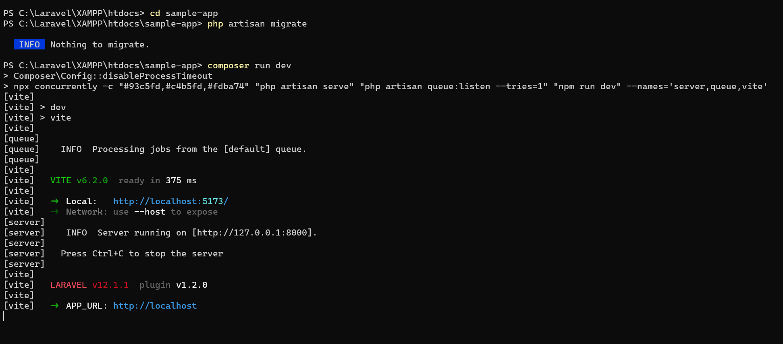

Figure 11. Starting Laravel’s local server using the ‘dev’ Composer script

Demonstrates running the Laravel development server using the ‘composer run dev’ command.

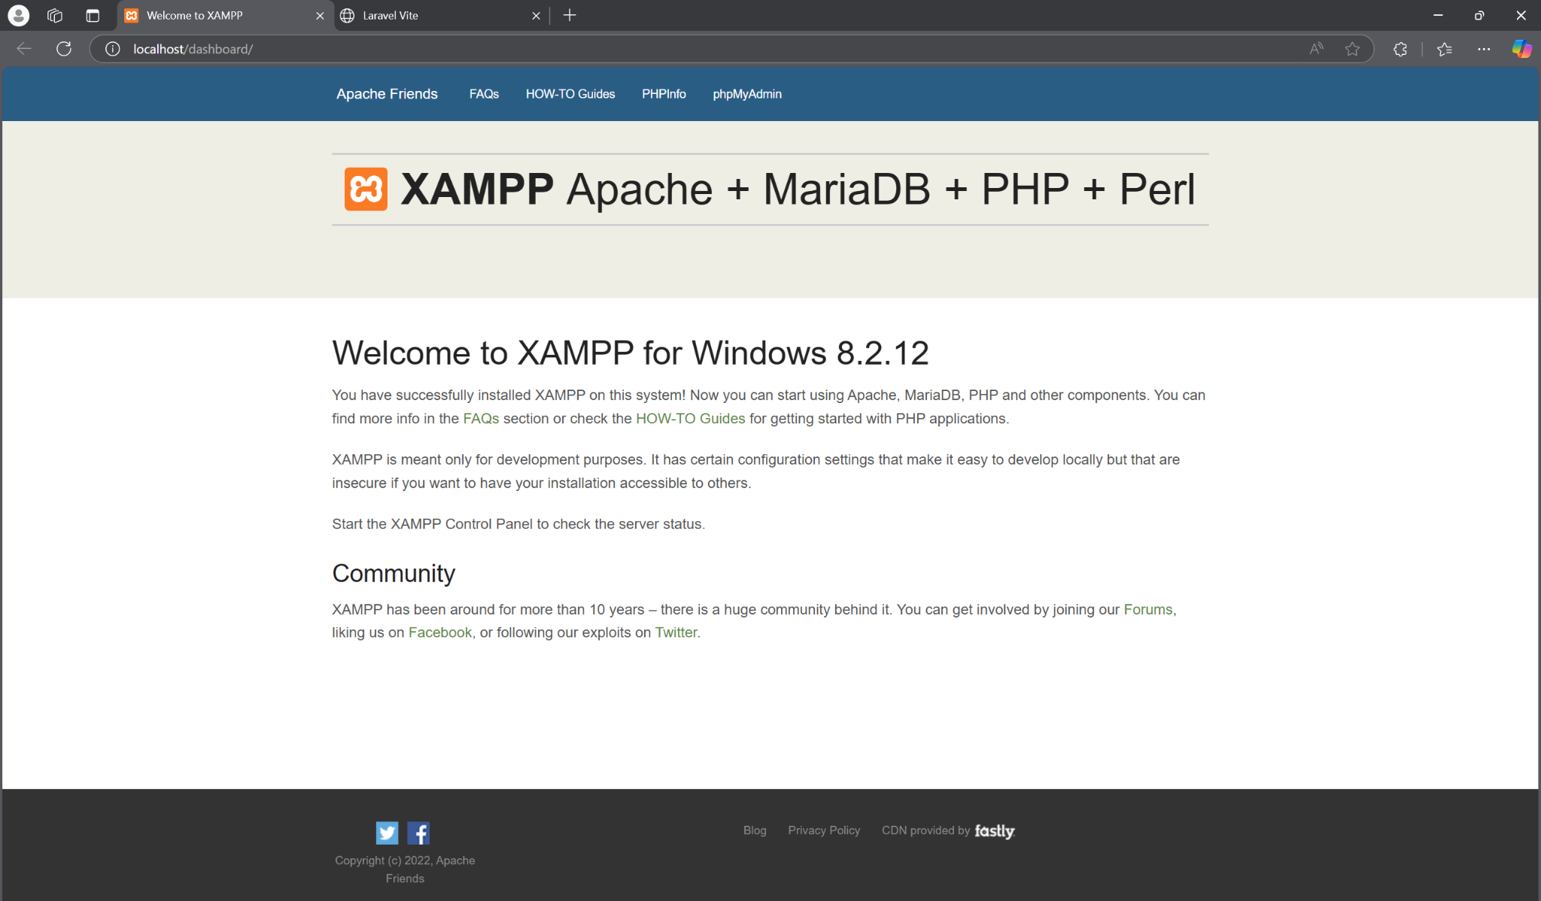

Figure 12. Accessing the newly created application

Illustrates opening the Laravel application in a web browser to confirm successful installation and setup.

# Chapter 3: Conclusion

The documentation provided complete guidelines about installing Laravel and Node.js through procedures explaining XAMPP and Composer and Node.js basic setup. With each software serves a fundamental function in Laravel development frameworks.

* **XAMPP** provides the necessary Apache and MySQL services to support Laravel's backend and database operations.
* **Composer** manages PHP dependencies, allowing Laravel and its required packages to be installed and updated efficiently.
* **Node.js** is essential for frontend asset management and builds tools like Laravel Mix to compile CSS and JavaScript files.

This combination of tools creates an entire development environment which ensures smooth operational connection between backend and frontend systems.